**Monarch Modelling Parameters**

*September 30, 2015*

The model consists of individual simulated Monarchs moving around a GIS landscape and laying eggs. Model inputs include the parameters and number of individual Monarchs. Model output is total number of eggs laid (and I’m pretty sure the number of eggs laid per habitat type).

Model has 3 major parts: *GIS landscape model*, *movement model*, and *egg-laying model.*

|  |  |  |
| --- | --- | --- |
| **Parameter** | **Values** | **Sources** |
| *Movement Model Parameters* | | |
| Perception Distance | 5 to 25 m | Zalucki and Kitching (1982b) |
| Field of View | ±30° to ±120° | n/a |
| Directionality | 0.2 to 0.8 | Zalucki and Kitching (1982b) |
| Step Length | 50 m to 125 m | n/a |
| Daily distance max | 15,000 m | Zalucki and Kitching (1985) (correct year is 1984) |
| *Egg-laying Model Parameters* | | |
| Max eggs laid per day | 100 | Based on 14-day lifespan with 1400 total eggs (Zalucki 1981) |
| Adult Lifespan | 14 days | Zalucki (1981), Zalucki et al. (1986) |
| Egg-laying rate | 1 egg per 2.5 m | Zalucki and Kitching (1982a,b) – 25 plants assumed to occur per 2.5 m, and 1 egg per 25 plants = 1 egg per 2.5 m |
| *GIS Landscape Model Parameters* | | |
| Preference Value | 0-1 (or 0.1-1) | Model compares preference value of current habitat patch to nearby habitat patch to calculate probability of leaving current patch |

**GIS Landscape Habitat Categories**

|  |  |
| --- | --- |
| **Habitat Type** | **Preference Value** |
| Glyphosate Corn (88%) | ? |
| Non-Glyphosate Corn (12%) |  |
| Glyphosate Soybean (96%) |  |
| Non-Glyphosate Soybean (4%) |  |
| Forest |  |
| Road ROW MW=0 (16%) |  |
| Road ROW MW=1-40 sq m (72%) |  |
| Road ROW MW=41-100 sq m (13%) |  |
| Railroad ROW |  |
| Med/High Intensity Development | 0 |
| Low Intensity/Open Space Dev URBAN |  |
| Low Intensity/Open Space Dev EXURBAN |  |
| Water/Barren/Other |  |
| Grass/Pasture |  |
| Grass/Pasture PADUS |  |
| Wetlands |  |
| Riparian Buffers/other NRS TBD |  |
| Bioreactors |  |
| Utility ROW |  |
| CRP (subcategories TBD) |  |

Each category needs a preference value – think of this in terms of the probability it will leave the current habitat for another type of habitat.

Probability of leaving current patch = preference value of new patch/(preference value new patch + preference value of current patch) = $P\left(leave\right)= \frac{{Pref}_{B}}{{Pref}_{B}+{Pref}_{A}}$

Distance moved per day declines over time according to: Dist = -1076t + 16077

This means that the monarch moves 15,000 m the first day, ~14000 m the next day, and so on, losing ~1000 m per day, until it travels only 1000 m on the 14th and final day of its short life.

Correlated Random Walk – correlated with current direction by randomly choosing a change in direction for the current heading – apparently a new heading is calculated for each step

The change in heading is calculated in radians as: $θ=±πR(1-D)$ where D is directionality and R is a random number between 0 and 1.

A directionality of 0.2 (low directionality) means at each step the heading can change from 0 to 144 degrees right or left with any value in that range being equally likely (uniformly distributed).

A directionality of 0.8 (high directionality) means at each step the heading can change from 0 to 36 degrees right or left with any value in that range being equally likely (uniformly distributed).

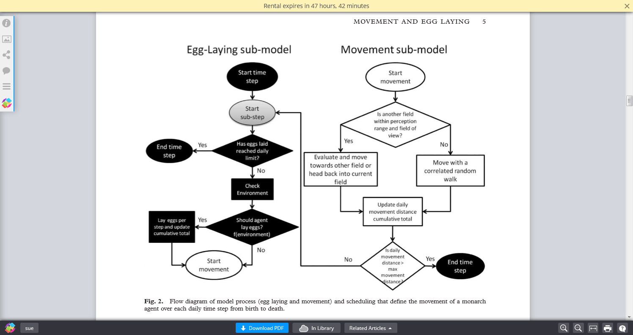

**Sources**

Zalucki, M. P. (1981). The effects of age and weather on egg laying in Danaus plexippus L.(Lepidoptera: Danaidae). Researches on Population Ecology, 23(2), 318-327.

Zalucki, M. P., & Kitching, R. L. (1982a). Dynamics of oviposition in Danaus plexippus (Insecta: Lepidoptera) on milkweed, Asclepias spp. Journal of Zoology, 198(1), 103-116.

Zalucki, M. P., & Kitching, R. L. (1982b). The analysis and description of movement in adult Danaus plexippus L.(Lepidoptera: Danainae). Behaviour, 80(3), 174-197.

Zalucki, M. P., & Kitching, R. L. (1985). The dynamics of adult Danaus plexippus L. around patches of its host plant Asclepias spp. J. Lepid. Soc, 38, 209-19. (***correct year is 1984***)

Zalucki, M. P., Daglish, G., Firempong, S., & Twine, P. (1986). The biology and ecology of Heliothis-armigera (Hubner) and Heliothis-Punctigera Wallengren (Lepidoptera, Noctuidae) in Australia-what do we know. Australian Journal of Zoology, 34(6), 779-814. (***Zalucki et al. 2015 list different authors, were they thinking of a different paper? Author list matches Zalucki et al. 1994 paper on the same species***)

**Parameter Discussion Priorities**

1. Lifespan – range 7-20
2. Daily Distance max, including assumption of decreasing max distance
3. Estimate prob of leaving for other patch type and prob of laying eggs and I will back-calculate pref values:

|  |  |  |  |  |  |  |  |
| --- | --- | --- | --- | --- | --- | --- | --- |
|  | Move Toward | | | | | | |
|  |  | **Corn/bean** | **Forest** | **Road ROWs** | **Grass/Pasture** | **Other** | **Wetlands** |
| Leave | **Corn/bean** | 0.5 | 0.5 | 0.9 | 0.9 | 0.5 | 0.9 |
| **Forest** | 0.5 | 0.5 | 0.9 | 0.9 | 0.5 | 0.9 |
| **Road ROWs** | 0.1 | 0.1 | 0.5 | 0.5 | 0.1 | 0.5 |
| **Grass/Pasture** | 0.1 | 0.1 | 0.5 | 0.5 | 0.1 | 0.5 |
| **Other** | 0.5 | 0.5 | 0.9 | 0.9 | 0.5 | 0.9 |
| **Wetlands** | 0.1 | 0.1 | 0.5 | 0.5 | 0.1 | 0.5 |

1. Eggs laid per day
2. Egg-laying rate – Zalucki et al 2015 indicated this is in a good place
3. Perception Distance
4. Field of View
5. Step Length
6. Directionality

Set a range to test for Monte Carlo – what is definitely too small or too big?

**What does Zalucki et al. 2015 say the model is sensitive to??**

Distance a butterfly travels from birth to death is most sensitive to directionality, then land cover (1% cover means more distance traveled), then step length.

Step length barely affected how many eggs were laid, indicating the parameter is good (end of Q1 Results). Reported detailed results for 50 m step length only.

**Literature Notes**

*Assumption: Daily distance max is 15,000 m*

**Zalucki, M. P., & Kitching, R. L. (1985). The dynamics of adult Danaus plexippus L. around patches of its host plant Asclepias spp. J. Lepid. Soc, 38, 209-19. (*correct year is 1984*)**

**Notes:** Conducted MR at 4 sites for 10 months. Butterflies moved among sites. Used Jolly-Seber model. Females survived on average at least 10 days. 2138 butterflies marked, 13% recaptured at least once. Only 5 marked individuals were captured at sites other than where they were last captured. From these 5 comes the 15,000 m estimate. Ranges from 0.7 to 2.48 km in a day though. But others stayed in patches right? Table citing Urquhart 1960 shows lifespan July-Aug in North American as 14.5 days.

*Assumption: Perception distance 5-25 m, directionality 0.2-0.8, and egg-laying rate*

**Zalucki, M. P., & Kitching, R. L. (1982b). The analysis and description of movement in adult Danaus plexippus L.(Lepidoptera: Danainae). Behaviour, 80(3), 174-197.**

9 males and 9 females

Directionality was normally distributed and went all 360 degrees.

*Assumption: Lifespan of 14 days and max 100 eggs per day*

**Zalucki, M. P. (1981). The effects of age and weather on egg laying in Danaus plexippus L.(Lepidoptera: Danaidae). Researches on Population Ecology, 23(2), 318-327.**

Monarchs were kept in flight cages 5x4x2 m with 3 species of milkweed. Fed 10% honey. Nov-Dec 1978. Age is show as day-degrees, calculated using an algorithm from another paper. Maxes out at 60 eggs/day. Longevity was average 4 weeks (28 days) in normal Brisbane summer temps. Did they double eggs per day and shorten life in half?? But 6-7 days before they lay eggs. Doesn’t actually mention how many eggs per lifetime. Awesome example of overfitted function.

*Derive Preference Values:*

***Stenoien, Nail, and Oberhauser. 2015. Habitat productivity and temporal patterns of Monarch egg densities in the Eastern United States.***

MLMP sites are divided into 6 categories: **gardens**, **natural areas** (reported by volunteers as prairies,

nature preserves, state parks, and state natural areas), **roadsides**, **crop-based agriculture**, **noncrop-based agriculture** (reported by volunteers as pastures, old fields, and Conservation Reserve Program (CRP) land), and **other** habitat types (city parks, golf courses, abandoned lots, backyards, undescribed sites, etc.).

Can’t get average egg density from what is presented in paper.

***Pleasants, J. M., & Oberhauser, K. S. (2013). Milkweed loss in agricultural fields because of herbicide use: effect on the monarch butterfly population. Insect Conservation and Diversity, 6(2), 135-144.***

Egg density was 0.2 eggs/plant in non-ag and 0.9 eggs/plant in ag.

Jesse and Obrycki 2003

**Simulation Parameters**

*GIS Milkweed Patches*

***Hartzler, R. G., & Buhler, D. D. (2000). Occurrence of common milkweed (Asclepias syriaca) in cropland and adjacent areas. Crop Protection, 19(5), 363-366.***

Field work conducted June-July 1999. Sampling: imposed 10 km grid on state – then divided state into 4 quarters I think? – then chose ten 10 km grid cells in each quarter. So forty 10 km grid cells. In each of the 40 cells, ten 50 m x 100 m areas were surveyed for MW. Each sample area was 100 m into the field, so 50 m wide and 100 m into field starting at road. ROW was usually 10 m and dominated by smooth brome.

In each sample area, MW patches were measured. Considered a patch if within 1 m of another MW. Solitary stems counted as 1m2 patches. He calls individual patches of habitat sites, so not a uniform number of sites per sample area.

Analyzed with ANOVA.

MW found in 71% of roadside sites, 46% of corn, 57% of soybean, etc.

It’s not clear to me how their area and percentages would translate to GIS polygons.

Cited a paper by Cramer and Burnside 1982 that found MW in various crops in Nebraska.

***Hartzler, R. G. (2010). Reduction in common milkweed (Asclepias syriaca) occurrence in Iowa cropland from 1999 to 2009. Crop Protection, 29(12), 1542-1544.***

*Map Grid:*

Zalucki et al. used 100 butterflies in 11.2 km2.

Story Co is 1490 km2, or 133x the area, so would need 100x133=133,000 butterflies for same coverage.

For 99 counties, 133,000 x 99 = 13,167,000 butterflies.

They used a 56m cell size (apparently 56m on a side).

The decimal degrees for the SW corner of Story Co is -93.698, 41.863 and NE corner is -93.232, 42.209.

The projection for the Repast Geography model shapefiles is Geographic Coordinate System/World/WGS 1984 and map units are decimal degrees.